**3rd Exam – IT 26 /L**

 

**The Vatican Cemetery: Online Cemetery System**

**Front-end – Jefford Inato**

**Back-end – Wendyll Erosido**

**MARCH 4, 2024**

1. **DASH BOARD DESIGN**

**SCREENSHOTS**

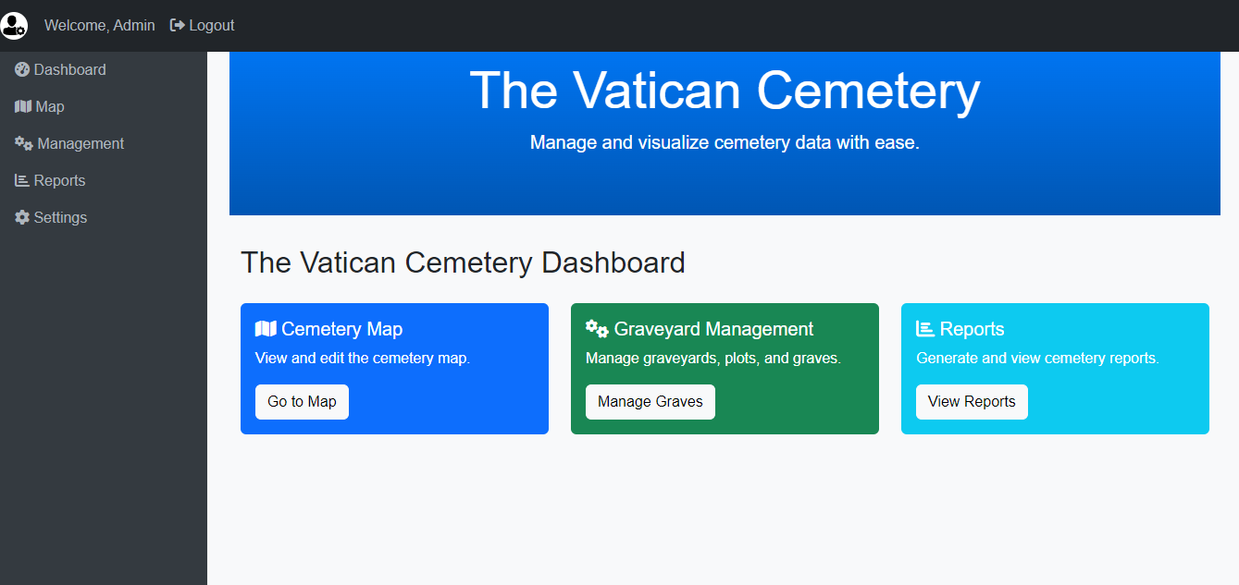

**DASH BOARD DESIGN**

1. **LOG-IN AND SIGN UP DESIGN**

**SCREENSHOTS**

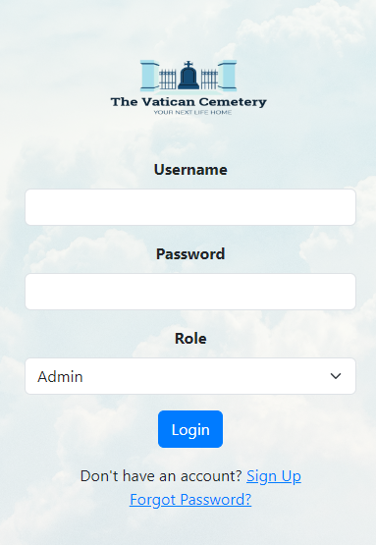 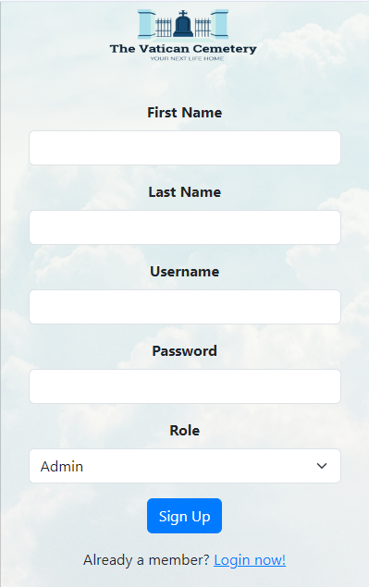

**Login Sign Up**

1. **CRUD DESIGN**

**SCREENSHOTS**

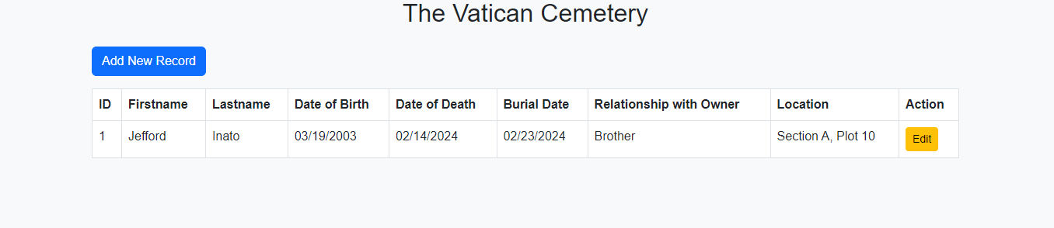

**CRUD DESIGN**

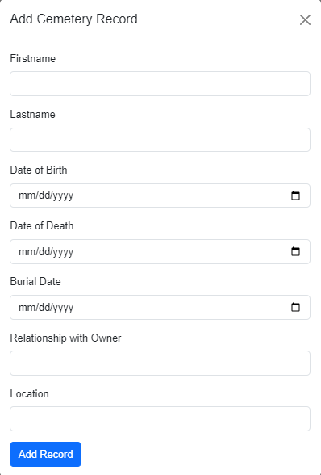

**Create**



**Read**

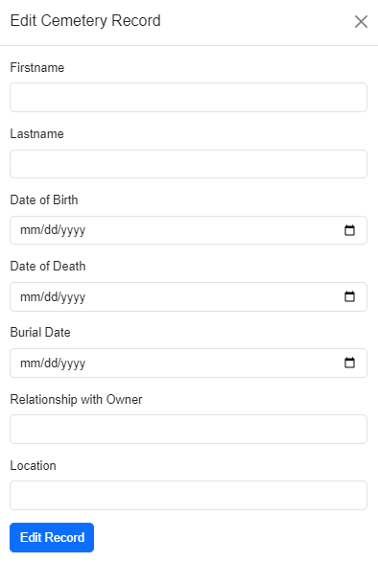

**Update**

**D- MAIN TRANSACTION PAGE DESIGN**

**SCREENSHOTS**

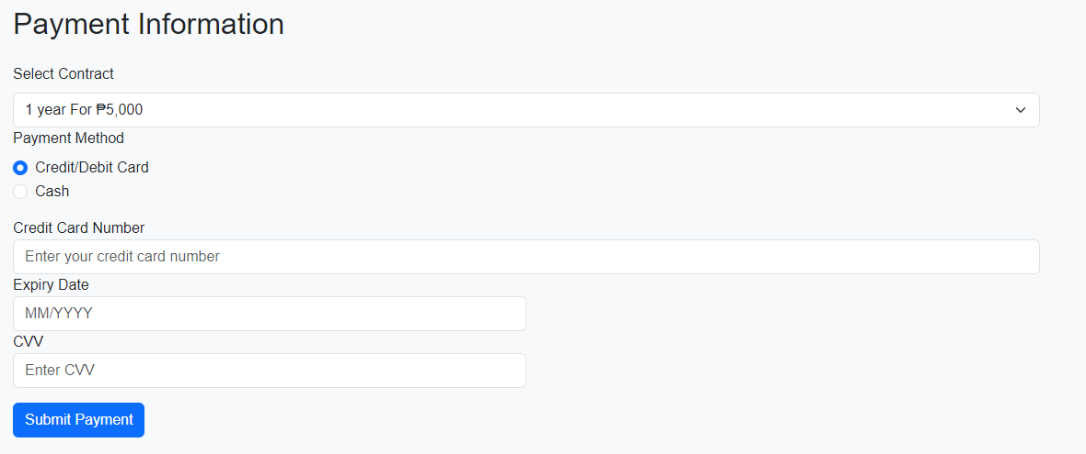

**Payment Information**

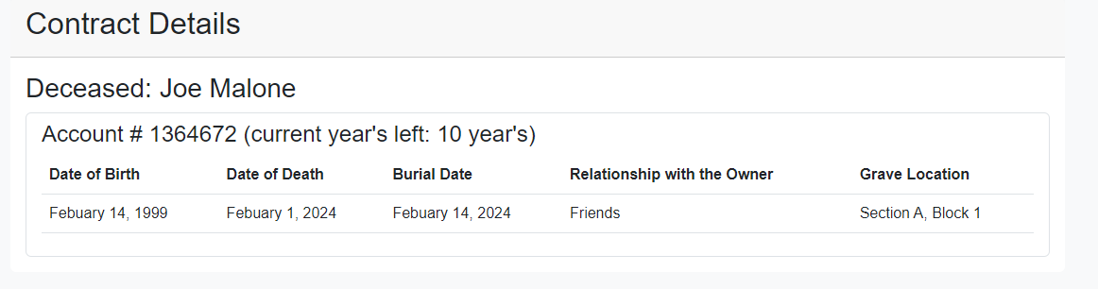

**Contract Details**

**E - DATABASE DESIGN (XAMPP)**

**Deceased Table**

|  |  |  |
| --- | --- | --- |
| **Field Names** | **Data Type** | **Length** |
| **PK - DeceasedID** | **Integer – Auto Increment** | **11** |
| **FirstName** | **Varchar** | **25** |
| **LastName** | **Varchar** | **50** |
| **DateofBirth** | **DateTime** | **None** |
| **DateofDeath** | **DateTime** | **None** |
| **BurialDate** | **DateTime** | **None** |
| **RelationshipWithOwner** | **Varchar** | **60** |
| **FK - OwnerID** | **Integer** | **11** |
| **FK - PlotID** | **Integer** | **11** |

**Owner Table**

|  |  |  |
| --- | --- | --- |
| **Field Names** | **Data Type** | **Length** |
| **PK - OwnerID** | **Integer – Auto Increment** | **11** |
| **FirstName** | **Varchar** | **50** |
| **LastName** | **Varchar** | **50** |
| **ContactNumber** | **Varchar** | **50** |
| **Address** | **Varchar** | **50** |

**Payment Table**

|  |  |  |
| --- | --- | --- |
| **Field Names** | **Data Type** | **Length** |
| **PK - PaymentID** | **Integer – Auto Increment** | **11** |
| **PaymentDate** | **DateTime** | **None** |
| **PaymentType** | **Varchar** | **70** |
| **Amount** | **Integer** | **70** |
| **Status** | **Varchar** | **50** |
| **FK – OwnerID** | **Integer** | **11** |
| **FK – TransactionID** | **Integer** | **11** |

**Plot Table**

|  |  |  |
| --- | --- | --- |
| **Field Names** | **Data Type** | **Length** |
| **PK - PlotID** | **Integer – Auto Increment** | **11** |
| **Section** | **Varchar** | **50** |
| **Block** | **Varchar** | **50** |
| **FK - DeceasedID** | **Integer** | **11** |

**Transactions Table**

|  |  |  |
| --- | --- | --- |
| **Field Names** | **Data Type** | **Length** |
| **PK - TransactionID** | **Integer – Auto Increment** | **11** |
| **TransacDate** | **DateTime** | **None** |
| **FK - OwnerID** | **Integer** | **11** |
| **FK - PlotID** | **Integer** | **11** |

**Users Table**

|  |  |  |
| --- | --- | --- |
| **Field Names** | **Data Type** | **Length** |
| **PK - UserID** | **Integer – Auto Increment** | **11** |
| **FirstName** | **Varchar** | **50** |
| **LastName** | **Varchar** | **50** |
| **Role** | **Varchar** | **20** |
| **Username** | **Varchar** | **20** |
| **Password** | **Varchar** | **20** |

**Notification Table**

|  |  |  |
| --- | --- | --- |
| **Field Names** | **Data Type** | **Length** |
| **PK – NotificationID** | **Integer – Auto Increment** | **11** |
| **NotifDate** | **Varchar** | **50** |
| **LastName** | **Varchar** | **50** |
| **FK – OwnerID** | **Integer** | **11** |
| **FK – PlotID** | **Integer** | **11** |
| **FK – UserID** | **Integer** | **11** |

**F – ENTITY RELATIONSHIP DIAGRAM**

**Screenshots**

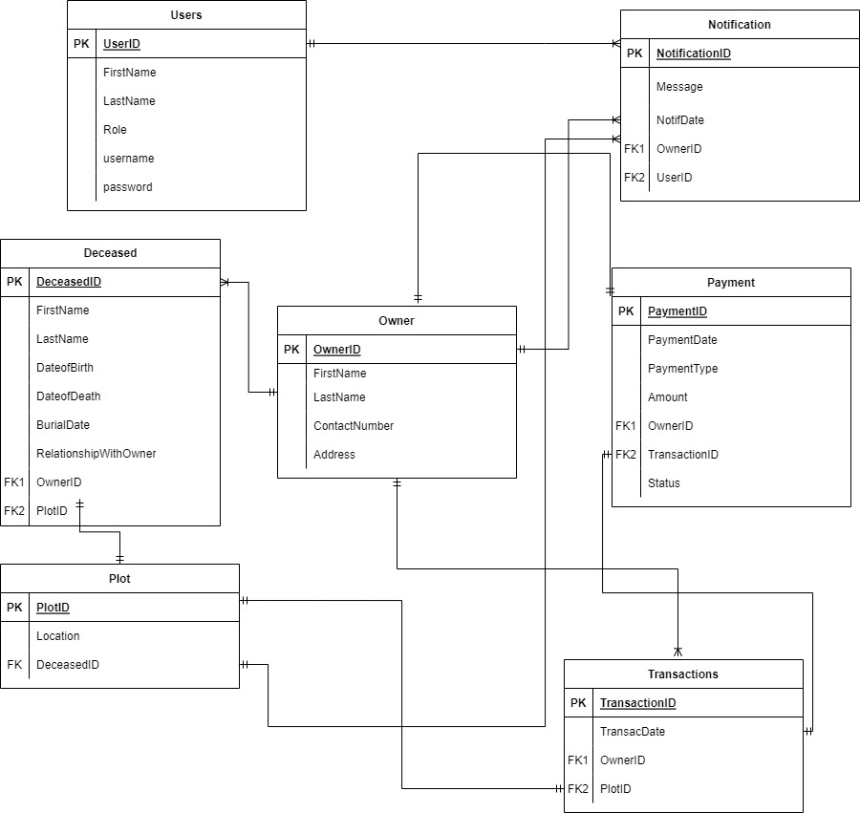

**G - SOURCE CODE**

**About.HTML:**

<!DOCTYPE html>

<html lang="en">

<head>

    <meta charset="UTF-8">

    <meta name="viewport" content="width=device-width, initial-scale=1.0">

    <title>The Vatican Cemetery</title>

    <link rel="stylesheet" href="https://cdn.jsdelivr.net/npm/bootstrap@5.3.0/dist/css/bootstrap.min.css">

    <link rel="stylesheet" href="styles.css">

</head>

<body>

    <!-- Navigation Bar -->

    <nav class="navbar navbar-expand-lg navbar-light bg-light">

        <div class="container">

            <img src="img/logo.png" alt="Logo" height="60" class="d-inline-block align-top">

            <button class="navbar-toggler" type="button" data-bs-toggle="collapse" data-bs-target="#navbarNav" aria-controls="navbarNav" aria-expanded="false" aria-label="Toggle navigation">

                <span class="navbar-toggler-icon"></span>

            </button>

            <div class="collapse navbar-collapse" id="navbarNav">

                <ul class="navbar-nav ms-auto">

                    <li class="nav-item">

                        <a class="nav-link" href="index.php">Home</a>

                    </li>

                    <li class="nav-item">

                        <a class="nav-link" href="contact.php">Contact</a>

                    </li>

                    <li class="nav-item">

                        <a class="nav-link" href="about.php">About</a>

                    </li>

                    <li class="nav-item">

                        <a class="nav-link" href="pay.php">Avail Now</a>

                    </li>

                    <li class="nav-item">

                        <a class="nav-link" href="notif.php">Notification</a>

                    </li>

                </ul>

            </div>

        </div>

    </nav>

    <div class="container mt-5">

        <h2 class="text-center">About Us</h2>

        <p>Welcome to the Vatican Cemetery Mapping System, where we strive to provide a comprehensive and efficient

            solution for mapping and managing cemetery data. Our platform is dedicated to preserving the legacy of

            departed loved ones and simplifying the navigation of cemetery grounds.</p>

        <p>With advanced mapping technology, our system allows users to locate gravesites, explore burial sections, and

            access vital information about the deceased. We understand the importance of maintaining a respectful and

            organized cemetery environment.</p>

        <p>At the Vatican Cemetery Mapping System, we are committed to maintaining the sanctity of resting places and

            assisting visitors in their journey of remembrance. Our mission is to provide a digital platform that

            facilitates a meaningful and respectful experience for all those connected to the cemetery.</p>

    </div>

    <script src="https://cdn.jsdelivr.net/npm/bootstrap@5.3.0/dist/js/bootstrap.bundle.min.js"></script>

</body>

</html>

**Admin.HTML:**

<!DOCTYPE html>

<html lang="en">

<head>

    <meta charset="UTF-8">

    <meta name="viewport" content="width=device-width, initial-scale=1.0">

    <title>ADMIN</title>

    <link rel="stylesheet" href="https://cdn.jsdelivr.net/npm/bootstrap@5.3.0/dist/css/bootstrap.min.css">

    <link rel="stylesheet" href="https://cdn.jsdelivr.net/npm/@fortawesome/fontawesome-free@6.0.0/css/all.min.css">

    <link rel="stylesheet" href="styles.css">

    <style>

    </style>

</head>

<body>

<nav class="navbar navbar-expand-md navbar-dark fixed-top bg-dark">

    <button class="navbar-toggler" type="button" data-toggle="collapse" data-target="#navbarCollapse"

            aria-controls="navbarCollapse" aria-expanded="false" aria-label="Toggle navigation">

        <span class="navbar-toggler-icon"></span>

    </button>

    <div class="collapse navbar-collapse" id="navbarCollapse">

        <ul class="navbar-nav ml-auto">

            <li class="nav-item">

                <div class="user-section">

                    <img src="img/admin.png" alt="Admin Avatar">

                    <span class="nav-link">Welcome, Admin</span>

                </div>

            </li>

            <li class="nav-item">

                <a class="nav-link" href="login.php"><i class="fas fa-sign-out-alt"></i> Logout</a>

            </li>

        </ul>

    </div>

</nav>

<div class="container-fluid">

    <div class="row">

        <!-- Sidebar -->

        <nav id="sidebar" class="col-md-3 col-lg-2 d-md-block sidebar">

            <div class="position-sticky">

                <ul class="nav flex-column">

                    <li class="nav-item">

                        <a class="nav-link active" href="admin.php">

                            <i class="fas fa-tachometer-alt"></i> Dashboard

                        </a>

                    </li>

                    <li class="nav-item">

                        <a class="nav-link" href="map.php">

                            <i class="fas fa-map"></i> Map

                        </a>

                    </li>

                    <li class="nav-item">

                        <a class="nav-link" href="grave_management.php">

                            <i class="fas fa-cogs"></i> Management

                        </a>

                    </li>

                    <li class="nav-item">

                        <a class="nav-link" href="reports.php">

                            <i class="fas fa-chart-bar"></i> Reports

                        </a>

                    </li>

                    <li class="nav-item">

                        <a class="nav-link" href="settings.php">

                            <i class="fas fa-cog"></i> Settings

                        </a>

                    </li>

                </ul>

            </div>

        </nav>

        <!-- Content -->

        <main class="col-md-9 ms-sm-auto col-lg-10 px-md-4 mt-3">

            <!-- Header Jumbotron -->

            <div class="jumbotron text-center">

                <h1 class="display-4">The Vatican Cemetery</h1>

                <p class="lead">Manage and visualize cemetery data with ease.</p>

            </div>

            <div class="container mt-4">

                <!-- Cemetery mapping dashboard content goes here -->

                <h2 class="mb-4">The Vatican Cemetery Dashboard</h2>

                <div class="row row-cols-1 row-cols-md-3 g-4">

                    <div class="col">

                        <div class="card bg-primary text-white">

                            <div class="card-body">

                                <h5 class="card-title"><i class="fas fa-map"></i> Cemetery Map</h5>

                                <p class="card-text">View and edit the cemetery map.</p>

                                <a href="map.php" class="btn btn-light">Go to Map</a>

                            </div>

                        </div>

                    </div>

                    <div class="col">

                        <div class="card bg-success text-white">

                            <div class="card-body">

                                <h5 class="card-title"><i class="fas fa-cogs"></i> Graveyard Management</h5>

                                <p class="card-text">Manage graveyards, plots, and graves.</p>

                                <a href="grave_management.php" class="btn btn-light">Manage Graves</a>

                            </div>

                        </div>

                    </div>

                    <div class="col">

                        <div class="card bg-info text-white">

                            <div class="card-body">

                                <h5 class="card-title"><i class="fas fa-chart-bar"></i> Reports</h5>

                                <p class="card-text">Generate and view cemetery reports.</p>

                                <a href="reports.php" class="btn btn-light">View Reports</a>

                            </div>

                        </div>

                    </div>

                </div>

            </div>

        </main>

    </div>

</div>

<!-- Bootstrap JS and Popper.js (optional) -->

<script src="https://cdn.jsdelivr.net/npm/bootstrap@5.3.0/dist/js/bootstrap.min.js"

        integrity="sha384-Z9tIoAfZeyd8Duhj4thN/LZud7tMTb5ST1Un6DD/3Ehep9+HAZPZZl+qC+7eZJLD"

        crossorigin="anonymous"></script>

</body>

</html>

**Contact.html:**

<!DOCTYPE html>

<html lang="en">

<head>

    <meta charset="UTF-8">

    <meta name="viewport" content="width=device-width, initial-scale=1.0">

    <title>The Vatican Cemetery</title>

    <link rel="stylesheet" href="https://cdn.jsdelivr.net/npm/bootstrap@5.3.0/dist/css/bootstrap.min.css">

    <link rel="stylesheet" href="styles.css">

</head>

<body>

    <!-- Navigation Bar -->

    <nav class="navbar navbar-expand-lg navbar-light bg-light">

        <div class="container">

            <img src="img/logo.png" alt="Logo" height="60" class="d-inline-block align-top">

            <button class="navbar-toggler" type="button" data-bs-toggle="collapse" data-bs-target="#navbarNav" aria-controls="navbarNav" aria-expanded="false" aria-label="Toggle navigation">

                <span class="navbar-toggler-icon"></span>

            </button>

            <div class="collapse navbar-collapse" id="navbarNav">

                <ul class="navbar-nav ms-auto">

                    <li class="nav-item">

                        <a class="nav-link" href="index.php">Home</a>

                    </li>

                    <li class="nav-item">

                        <a class="nav-link" href="contact.php">Contact</a>

                    </li>

                    <li class="nav-item">

                        <a class="nav-link" href="about.php">About</a>

                    </li>

                    <li class="nav-item">

                        <a class="nav-link" href="pay.php">Avail Now</a>

                    </li>

                    <li class="nav-item">

                        <a class="nav-link" href="notif.php">Notification</a>

                    </li>

                </ul>

            </div>

        </div>

    </nav>

    <div class="container mt-5">

        <h2 class="text-center">Contact Us</h2>

        <p>Contact our support team for any inquiries or assistance:</p>

        <ul>

            <li>Email: Google.com</li>

            <li>Phone: +123 456 789</li>

            <li>Address: University of Mindanao</li>

        </ul>

    </div>

    <script src="https://cdn.jsdelivr.net/npm/bootstrap@5.3.0/dist/js/bootstrap.bundle.min.js"></script>

</body>

</html>

**Grave_management.html:**

<!DOCTYPE html>

<html lang="en">

<head>

    <meta charset="UTF-8">

    <meta name="viewport" content="width=device-width, initial-scale=1.0">

    <title>Cemetery Mapping</title>

    <link href="https://cdn.jsdelivr.net/npm/bootstrap@5.3.0/dist/css/bootstrap.min.css" rel="stylesheet">

    <link rel="stylesheet" href="styles.css">

</head>

<body>

    <div class="container">

        <header class="text-center mb-4">

            <h2>The Vatican Cemetery</h2>

        </header>

        <!-- Add Button Triggering Add Modal -->

        <button type="button" class="btn btn-primary mb-3" data-bs-toggle="modal" data-bs-target="#addModal">

            Add New Record

        </button>

        <!-- Cemetery Mapping Table -->

        <div class="table-responsive">

            <table class="table table-bordered table-hover">

                <thead>

                    <tr>

                        <th>ID</th>

                        <th>Firstname</th>

                        <th>Lastname</th>

                        <th>Date of Birth</th>

                        <th>Date of Death</th>

                        <th>Burial Date</th>

                        <th>Relationship with Owner</th>

                        <th>Location</th>

                        <th>Action</th>

                    </tr>

                </thead>

                <tbody>

                    <!-- Sample Data -->

                    <tr>

                        <td>1</td>

                        <td>Jefford</td>

                        <td>Inato</td>

                        <td>03/19/2003</td>

                        <td>02/14/2024</td>

                        <td>02/23/2024</td>

                        <td>Brother</td>

                        <td>Section A, Plot 10</td>

                        <td>

                            <!-- Edit and Delete Buttons Triggering Modals -->

                            <button type="button" class="btn btn-warning btn-sm" data-bs-toggle="modal"

                                data-bs-target="#editModal">

                                <i class="bi bi-pencil"></i> Edit

                            </button>

                            <button type="button" class="btn btn-danger btn-sm" data-bs-toggle="modal"

                                data-bs-target="#deleteModal">

                                <i class="bi bi-trash"></i> Delete

                            </button>

                        </td>

                    </tr>

                    <!-- Add more rows as needed -->

                </tbody>

            </table>

        </div>

    </div>

    <!-- Add Modal -->

    <div class="modal fade" id="addModal" tabindex="-1" aria-labelledby="addModalLabel" aria-hidden="true">

        <!-- Add Modal content here -->

        <div class="modal-dialog">

            <div class="modal-content">

                <div class="modal-header">

                    <h5 class="modal-title" id="addModalLabel">Add Cemetery Record</h5>

                    <button type="button" class="btn-close" data-bs-dismiss="modal" aria-label="Close"></button>

                </div>

                <div class="modal-body">

                    <!-- Add Form Content -->

                    <form>

                        <!-- Add your form fields here (Firstname, Lastname, DateofBirth, etc.) -->

                        <div class="mb-3">

                            <label for="addFirstname" class="form-label">Firstname</label>

                            <input type="text" class="form-control" id="addFirstname" required>

                        </div>

                        <div class="mb-3">

                            <label for="addLastname" class="form-label">Lastname</label>

                            <input type="text" class="form-control" id="addLastname" required>

                        </div>

                        <div class="mb-3">

                            <label for="addDoB" class="form-label">Date of Birth</label>

                            <input type="date" class="form-control" id="addDoB" required>

                        </div>

                        <div class="mb-3">

                            <label for="addDoD" class="form-label">Date of Death</label>

                            <input type="date" class="form-control" id="addDoD" required>

                        </div>

                        <div class="mb-3">

                            <label for="addBurialDate" class="form-label">Burial Date</label>

                            <input type="date" class="form-control" id="addBurialDate" required>

                        </div>

                        <div class="mb-3">

                            <label for="addRelationshipWithOwner" class="form-label">Relationship with Owner</label>

                            <input type="text" class="form-control" id="addRelationshipWithOwner" required>

                        </div>

                        <div class="mb-3">

                            <label for="addLocation" class="form-label">Location</label>

                            <input type="text" class="form-control" id="addLocation" required>

                        </div>

                        <!-- Add other fields similarly -->

                        <button type="button" class="btn btn-primary">Add Record</button>

                    </form>

                </div>

            </div>

        </div>

    </div>

    <!-- Edit Modal -->

    <div class="modal fade" id="editModal" tabindex="-1" aria-labelledby="editModalLabel" aria-hidden="true">

        <!-- Edit Modal content here -->

        <div class="modal-dialog">

            <div class="modal-content">

                <div class="modal-header">

                    <h5 class="modal-title" id="editModalLabel">Edit Cemetery Record</h5>

                    <button type="button" class="btn-close" data-bs-dismiss="modal" aria-label="Close"></button>

                </div>

                <div class="modal-body">

                    <!-- Edit Form Content -->

                    <form>

                        <!-- Add your form fields here (Firstname, Lastname, DateofBirth, etc.) -->

                        <div class="mb-3">

                            <label for="editFirstname" class="form-label">Firstname</label>

                            <input type="text" class="form-control" id="editFirstname" required>

                        </div>

                        <div class="mb-3">

                            <label for="editLastname" class="form-label">Lastname</label>

                            <input type="text" class="form-control" id="editLastname" required>

                        </div>

                        <div class="mb-3">

                            <label for="editDoB" class="form-label">Date of Birth</label>

                            <input type="date" class="form-control" id="editDoB" required>

                        </div>

                        <div class="mb-3">

                            <label for="editDoD" class="form-label">Date of Death</label>

                            <input type="date" class="form-control" id="editDoD" required>

                        </div>

                        <div class="mb-3">

                            <label for="editBurialDate" class="form-label">Burial Date</label>

                            <input type="date" class="form-control" id="editBurialDate" required>

                        </div>

                        <div class="mb-3">

                            <label for="editRelationshipWithOwner" class="form-label">Relationship with Owner</label>

                            <input type="text" class="form-control" id="editRelationshipWithOwner" required>

                        </div>

                        <div class="mb-3">

                            <label for="editLocation" class="form-label">Location</label>

                            <input type="text" class="form-control" id="editLocation" required>

                        </div>

                        <!-- Add other fields similarly -->

                        <button type="button" class="btn btn-primary">Edit Record</button>

                    </form>

                </div>

            </div>

        </div>

    </div>

    <!-- Delete Modal -->

    <div class="modal fade" id="deleteModal" tabindex="-1" aria-labelledby="deleteModalLabel" aria-hidden="true">

        <div class="modal-dialog">

            <div class="modal-content">

                <div class="modal-header">

                    <h5 class="modal-title" id="deleteModalLabel">Confirm Delete</h5>

                    <button type="button" class="btn-close" data-bs-dismiss="modal" aria-label="Close"></button>

                </div>

                <div class="modal-body">

                    <p>Are you sure you want to delete this record?</p>

                </div>

                <div class="modal-footer">

                    <button type="button" class="btn btn-secondary" data-bs-dismiss="modal">Cancel</button>

                    <button type="button" class="btn btn-danger" id="deleteRecordBtn">Delete</button>

                </div>

            </div>

        </div>

    </div>

    <script src="https://cdn.jsdelivr.net/npm/bootstrap@5.3.0/dist/js/bootstrap.bundle.min.js"></script>

</body>

</html>

**Index.html:**

<!DOCTYPE html>

<html lang="en">

<head>

    <meta charset="UTF-8">

    <meta name="viewport" content="width=device-width, initial-scale=1.0">

    <title>The Vatican Cemetery</title>

    <link rel="stylesheet" href="https://cdn.jsdelivr.net/npm/bootstrap@5.3.0/dist/css/bootstrap.min.css">

    <link rel="stylesheet" href="https://cdnjs.cloudflare.com/ajax/libs/animate.css/4.1.1/animate.min.css">

    <link rel="stylesheet" href="styles.css">

</head>

<body>

<!-- Navigation Bar -->

<nav class="navbar navbar-expand-lg navbar-light bg-light">

    <div class="container">

        <img src="img/logo.png" alt="Logo" height="60" class="d-inline-block align-top">

        <button class="navbar-toggler" type="button" data-bs-toggle="collapse" data-bs-target="#navbarNav" aria-controls="navbarNav" aria-expanded="false" aria-label="Toggle navigation">

            <span class="navbar-toggler-icon"></span>

        </button>

        <div class="collapse navbar-collapse" id="navbarNav">

            <ul class="navbar-nav ms-auto">

                <li class="nav-item">

                    <a class="nav-link" href="index.php">Home</a>

                </li>

                <li class="nav-item">

                    <a class="nav-link" href="contact.php">Contact</a>

                </li>

                <li class="nav-item">

                    <a class="nav-link" href="about.php">About</a>

                </li>

                <li class="nav-item">

                    <a class="nav-link" href="pay.php">Avail Now</a>

                </li>

                <li class="nav-item">

                    <a class="nav-link" href="notif.php">Notification</a>

                </li>

            </ul>

        </div>

    </div>

</nav>

<!-- Hero Section -->

<section class="hero bg-primary text-white text-center py-5">

    <div class="container">

        <div class="row justify-content-center align-items-center" style="height: 100vh;">

            <div class="col-md-8 col-lg-6">

                <h2 class="display-4">Find Peaceful Resting Places</h2>

                <p class="lead">Explore our interactive map to locate and remember your loved ones in serene cemeteries.</p>

                <a href="map.php" class="btn btn-light btn-lg">Explore Map</a>

            </div>

        </div>

    </div>

</section>

<!-- Features Section -->

<section id="explore" class="features text-center py-5">

    <div class="container">

        <h2 class="mb-5">Discover our Features</h2>

        <div class="row">

            <!-- Feature Box: Interactive Maps -->

            <div class="col-lg-4 mb-4 animate__animated animate__fadeIn">

                <div class="card">

                    <img src="img/map.png" alt="Map Icon" class="card-img-top">

                    <div class="card-body">

                        <h3 class="card-title">Interactive Maps</h3>

                        <p class="card-text">Discover burial sites with our user-friendly interactive maps.</p>

                    </div>

                </div>

            </div>

            <!-- Feature Box: Enhanced User Experience -->

            <div class="col-lg-4 mb-4 animate__animated animate__fadeIn">

                <div class="card">

                    <img src="img/user.png" alt="User Icon" class="card-img-top">

                    <div class="card-body">

                        <h3 class="card-title">Enhanced User Experience</h3>

                        <p class="card-text">Designed to provide an exceptional user experience for all visitors.</p>

                    </div>

                </div>

            </div>

            <!-- Feature Box: Effortless Search -->

            <div class="col-lg-4 mb-4 animate__animated animate__fadeIn">

                <div class="card">

                    <img src="img/search.png" alt="Search Icon" class="card-img-top">

                    <div class="card-body">

                        <h3 class="card-title">Effortless Search</h3>

                        <p class="card-text">Efficiently search for resting places using our advanced search features.</p>

                    </div>

                </div>

            </div>

        </div>

    </div>

</section>

<!-- Call-to-Action Section -->

<section class="cta text-center py-5">

    <div class="container">

        <h2>Start Your Journey Today</h2>

        <p>Explore the beauty of cemeteries and cherish the memories of your loved ones.</p>

        <a href="signup.php" class="btn btn-primary btn-lg">Sign Up Now</a>

    </div>

</section>

<!-- Footer Section -->

<footer class="footer bg-light text-dark text-center py-3">

    <div class="container">

        <p>&copy; 2024 The Vatican Cemetery. All rights reserved.</p>

    </div>

</footer>

<script src="https://cdn.jsdelivr.net/npm/bootstrap@5.3.0/dist/js/bootstrap.bundle.min.js"></script>

</body>

</html>

**Login.html:**

<!DOCTYPE html>

<html lang="en">

<head>

    <meta charset="UTF-8">

    <meta name="viewport" content="width=device-width, initial-scale=1.0">

    <title>The Vatican Cemetery</title>

    <link rel="stylesheet" href="https://cdn.jsdelivr.net/npm/bootstrap@5.3.0/dist/css/bootstrap.min.css">

</head>

<style>

</style>

<body>

    <div class="container">

        <div class="card shadow">

            <div class="card-body text-center">

                <img src="img/logo.png" alt="Logo" class="card-img-top mb-4">

                <!-- Your Login form goes here -->

                <form action="login_process.php" method="post">

                    <div class="mb-3">

                        <label for="username" class="form-label">Username</label>

                        <input type="text" class="form-control" id="username" name="username" required>

                    </div>

                    <div class="mb-3">

                        <label for="password" class="form-label">Password</label>

                        <input type="password" class="form-control" id="password" name="password" required>

                    </div>

                    <div class="mb-3">

                        <label for="role" class="form-label">Role</label>

                        <select class="form-select" id="role" name="role" required>

                            <option value="admin">Admin</option>

                            <option value="user">User</option>

                        </select>

                    </div>

                    <button type="submit" class="btn btn-primary btn-block">Login</button>

                </form>

                <div class="mt-3">

                    <p class="mb-0">Don't have an account? <a href="signup.php">Sign Up</a></p>

                </div>

            </div>

        </div>

    </div>

    <script src="https://cdn.jsdelivr.net/npm/bootstrap@5.3.0/dist/js/bootstrap.bundle.min.js"></script>

</body>

</html>

**Map.html:**

<!DOCTYPE html>

<html lang="en">

<head>

    <meta charset="UTF-8">

    <meta name="viewport" content="width=device-width, initial-scale=1.0">

    <title>Cemetery Mapping</title>

    <link rel="stylesheet" href="https://cdn.jsdelivr.net/npm/bootstrap@5.3.0/dist/css/bootstrap.min.css">

    <link rel="stylesheet" href="styles.css">

</head>

<body>

    <!-- Navigation Bar -->

    <nav class="navbar navbar-expand-lg navbar-light bg-light">

        <div class="container">

            <img src="img/logo.png" alt="Logo" height="60" class="d-inline-block align-top">

            <button class="navbar-toggler" type="button" data-bs-toggle="collapse" data-bs-target="#navbarNav"

                aria-controls="navbarNav" aria-expanded="false" aria-label="Toggle navigation">

                <span class="navbar-toggler-icon"></span>

            </button>

            <div class="collapse navbar-collapse" id="navbarNav">

                <ul class="navbar-nav ms-auto">

                    <li class="nav-item">

                        <a class="nav-link" href="index.php">Home</a>

                    </li>

                    <li class="nav-item">

                        <a class="nav-link" href="contact.php">Contact</a>

                    </li>

                    <li class="nav-item">

                        <a class="nav-link" href="about.php">About</a>

                    </li>

                    <li class="nav-item">

                        <a class="nav-link" href="pay.php">Avail Now</a>

                    </li>

                    <li class="nav-item">

                        <a class="nav-link" href="notif.php">Notification</a>

                    </li>

                </ul>

            </div>

        </div>

    </nav>

<!-- Cemetery Container -->

<div class="container mt-5">

    <!-- Dropdown (Combobox) to Select Cemetery Section -->

    <div class="d-flex justify-content-start mb-3">

        <select id="sectionSelect" class="form-select" name="section" required>

            <option value="section">Choose a Section</option>

            <option value="sectionA">Section A</option>

            <option value="sectionB">Section B</option>

            <option value="sectionC">Section C</option>

        </select>

    </div>

    <!-- Container to display dynamically generated grid content -->

    <div id="gridContainer" style="display: grid; grid-template-columns: repeat(8, 1fr); gap: 10px;"></div>

</div>

            <!-- Container for Deceased Person -->

            <div class="container mt-3">

                <h3>Deceased Person</h3>

                <!-- Search Bar with Search Button -->

                <div class="input-group mb-3">

                    <input type="text" class="form-control" placeholder="Search for a person" aria-label="Search for a person" aria-describedby="button-addon2">

                    <button class="btn btn-outline-secondary" type="button" id="button-addon2">Search</button>

                </div>

                <!-- Table -->

                <table class="table">

                    <thead>

                        <tr>

                            <th scope="col">#</th>

                            <th scope="col">Name</th>

                            <th scope="col">Location</th>

                        </tr>

                    </thead>

                    <tbody>

                        <tr>

                            <th scope="row"></th>

                            <td></td>

                            <td></td>

                            <td></td>

                        </tr>

                        <!-- Add more rows as needed -->

                    </tbody>

                </table>

            </div>

        </div>

    </div>

<!-- JavaScript to Handle Dropdown Selection -->

<script src="https://cdn.jsdelivr.net/npm/bootstrap@5.3.0/dist/js/bootstrap.bundle.min.js"></script>

<script src="script.js"></script>

</body>

</html>

**Notif.html:**

<!DOCTYPE html>

<html lang="en">

    <link href="//maxcdn.bootstrapcdn.com/bootstrap/4.0.0/css/bootstrap.min.css" rel="stylesheet" id="bootstrap-css">

<head>

    <link rel="stylesheet" href="https://fonts.googleapis.com/css?family=Roboto:300,400,500,700|Material+Icons">

    <link rel="stylesheet" href="https://unpkg.com/bootstrap-material-design@4.1.1/dist/css/bootstrap-material-design.min.css" integrity="sha384-wXznGJNEXNG1NFsbm0ugrLFMQPWswR3lds2VeinahP8N0zJw9VWSopbjv2x7WCvX" crossorigin="anonymous">

    <link href="https://maxcdn.bootstrapcdn.com/font-awesome/latest/css/font-awesome.min.css" rel="stylesheet">

    <link rel="stylesheet" type="text/css" href="https://fonts.googleapis.com/css?family=Roboto:300,400,500,700|Roboto+Slab:400,700|Material+Icons">

</head>

<body>

       <!-- Navigation Bar -->

       <nav class="navbar navbar-expand-lg navbar-light bg-light">

        <div class="container">

            <img src="img/logo.png" alt="Logo" height="60" class="d-inline-block align-top">

            <button class="navbar-toggler" type="button" data-bs-toggle="collapse" data-bs-target="#navbarNav"

                aria-controls="navbarNav" aria-expanded="false" aria-label="Toggle navigation">

                <span class="navbar-toggler-icon"></span>

            </button>

            <div class="collapse navbar-collapse" id="navbarNav">

                <ul class="navbar-nav ms-auto">

                    <li class="nav-item">

                        <a class="nav-link" href="index.php">Home</a>

                    </li>

                    <li class="nav-item">

                        <a class="nav-link" href="contact.php">Contact</a>

                    </li>

                    <li class="nav-item">

                        <a class="nav-link" href="about.php">About</a>

                    </li>

                    <li class="nav-item">

                        <a class="nav-link" href="pay.php">Avail Now</a>

                    </li>

                    <li class="nav-item">

                        <a class="nav-link" href="notif.php">Notifacation</a>

                    </li>

                </ul>

            </div>

        </div>

    </nav>

    <div class="container mt-5">

        <div class="title">

          <h3>Notifications</h3>

        </div>

    </div>

    <div class="alert alert-info">

        <div class="container">

            <div class="alert-icon">

                <i class="material-icons">info_outline</i>

            </div>

            <button type="button" class="close" data-dismiss="alert" aria-label="Close">

                <span aria-hidden="true"><i class="material-icons">clear</i></span>

            </button>

            <b>Info alert:</b> Your Yearly Contract is nearly Expired!

        </div>

    </div>

    <div class="alert alert-success">

        <div class="container">

            <div class="alert-icon">

                <i class="material-icons">check</i>

            </div>

            <button type="button" class="close" data-dismiss="alert" aria-label="Close">

                <span aria-hidden="true"><i class="material-icons">clear</i></span>

            </button>

            <b>Payment Alert :</b> You've Successfully Paid 10 year's Extended Contract For ₱10.99!

        </div>

    </div>

    <script src="//maxcdn.bootstrapcdn.com/bootstrap/4.0.0/js/bootstrap.min.js"></script>

<script src="//cdnjs.cloudflare.com/ajax/libs/jquery/3.2.1/jquery.min.js"></script>

    <script src="https://unpkg.com/bootstrap-material-design@4.1.1/dist/js/bootstrap-material-design.js" integrity="sha384-CauSuKpEqAFajSpkdjv3z9t8E7RlpJ1UP0lKM/+NdtSarroVKu069AlsRPKkFBz9" crossorigin="anonymous"></script>

</body>

</html>

**Pay.html:**

<!DOCTYPE html>

<html lang="en">

<head>

    <meta charset="UTF-8">

    <meta name="viewport" content="width=device-width, initial-scale=1.0">

    <title>Payment</title>

    <link href="https://cdn.jsdelivr.net/npm/bootstrap@5.3.0/dist/css/bootstrap.min.css" rel="stylesheet">

    <link rel="stylesheet" href="styles.css">

</head>

<body>

<nav class="navbar navbar-expand-lg navbar-light bg-light">

    <div class="container">

        <img src="img/logo.png" alt="Logo" height="60" class="d-inline-block align-top">

        <button class="navbar-toggler" type="button" data-bs-toggle="collapse" data-bs-target="#navbarNav"

            aria-controls="navbarNav" aria-expanded="false" aria-label="Toggle navigation">

            <span class="navbar-toggler-icon"></span>

        </button>

        <div class="collapse navbar-collapse" id="navbarNav">

            <ul class="navbar-nav ms-auto">

                <li class="nav-item">

                    <a class="nav-link" href="index.php">Home</a>

                </li>

                <li class="nav-item">

                    <a class="nav-link" href="contact.php">Contact</a>

                </li>

                <li class="nav-item">

                    <a class="nav-link" href="about.php">About</a>

                </li>

                <li class="nav-item">

                    <a class="nav-link" href="pay.php">Avail Now</a>

                </li>

                <li class="nav-item">

                    <a class="nav-link" href="notif.php">Notification</a>

                </li>

            </ul>

        </div>

    </div>

</nav>

<div class="container mt-5">

    <h2 class="mb-4">Payment Information</h2>

    <form>

        <div class="mb-3" class="d-flex justify-content-start mb-3">

            <label for="amount" class="form-label">Select Contract</label>

            <div>

                <select id="sectionSelect" class="form-select" name="section" required>

                    <option value="sectionA">1 year For ₱5,000</option>

                    <option value="sectionB">5 year's For ₱20,000</option>

                    <option value="sectionC">10 year's For ₱40,000 </option>

                    <option value="custom">Custom Contract</option>

                </select>

            </div>

            <div id="customContractFields" style="display: none;">

                <div class="mb-3">

                    <label for="customYear" class="form-label">Custom Contract Year</label>

                    <input type="text" class="form-control" id="customYear" placeholder="Enter the custom contract year">

                </div>

                <div class="mb-3">

                    <label for="customAmount" class="form-label">Custom Contract Amount</label>

                    <input type="text" class="form-control" id="customAmount" placeholder="Enter the custom contract amount">

                </div>

            </div>

            <div class="mb-3">

                <label class="form-label">Payment Method</label>

                <div class="form-check">

                    <input class="form-check-input" type="radio" name="paymentMethod" id="cardPayment" value="card"

                        checked>

                    <label class="form-check-label" for="cardPayment">

                        Credit/Debit Card

                    </label>

                </div>

                <div class="form-check">

                    <input class="form-check-input" type="radio" name="paymentMethod" id="cashPayment" value="cash">

                    <label class="form-check-label" for="cashPayment">

                        Cash

                    </label>

                </div>

            </div>

            <div id="cardInfoContainer">

                <!-- Card Information Fields -->

                <div class="form-group">

                    <label for="creditCard">Credit Card Number</label>

                    <input type="text" class="form-control" id="creditCard" placeholder="Enter your credit card number"

                        required>

                </div>

                <div class="form-row">

                    <div class="form-group col-md-6">

                        <label for="expiryDate">Expiry Date</label>

                        <input type="text" class="form-control" id="expiryDate" placeholder="MM/YYYY" required>

                    </div>

                    <div class="form-group col-md-6">

                        <label for="cvv">CVV</label>

                        <input type="text" class="form-control" id="cvv" placeholder="Enter CVV" required>

                    </div>

                </div>

            </div>

            <div id="cashInfoContainer" style="display: none;">

                <!-- Cash Information Fields -->

                <div class="form-group">

                    <label for="cashAmount">Cash Amount</label>

                    <input type="text" class="form-control" id="cashAmount" placeholder="Enter the cash amount" required>

                </div>

            </div>

            <button type="submit" class="btn btn-primary mt-3"><a class="nav-link" href="transac.php">Submit Payment</a></button>

        </div>

    </form>

</div>

<!-- Bootstrap JS (Optional, if you want to use Bootstrap features that require JS) -->

<script src="https://cdn.jsdelivr.net/npm/bootstrap@5.3.0/dist/js/bootstrap.bundle.min.js"></script>

<!-- Your custom script.js (Add this line) -->

<script src="script.js"></script>

</body>

</html>

**Signup.html:**

<!DOCTYPE html>

<html lang="en">

<head>

    <meta charset="UTF-8">

    <meta name="viewport" content="width=device-width, initial-scale=1.0">

    <title>Sign Up</title>

    <link rel="stylesheet" href="https://cdn.jsdelivr.net/npm/bootstrap@5.3.0/dist/css/bootstrap.min.css">

</head>

<style>

</style>

<body>

    <div class="container">

        <div class="card shadow">

            <div class="card-body text-center">

                <img src="img/logo.png" alt="Logo" class="card-img-top mb-4">

                <!-- Your signup form goes here -->

                <form>

                    <div class="mb-3">

                        <label for="firstName" class="form-label">First Name</label>

                        <input type="text" class="form-control" id="firstName" name="firstName" required>

                    </div>

                    <div class="mb-3">

                        <label for="lastName" class="form-label">Last Name</label>

                        <input type="text" class="form-control" id="lastName" name="lastName" required>

                    </div>

                    <div class="mb-3">

                        <label for="username" class="form-label">Username</label>

                        <input type="text" class="form-control" id="username" name="username" required>

                    </div>

                    <div class="mb-3">

                        <label for="password" class="form-label">Password</label>

                        <input type="password" class="form-control" id="password" name="password" required>

                    </div>

                    <div class="mb-3">

                        <label for="role" class="form-label">Role</label>

                        <select class="form-select" id="role" name="role" required>

                            <option value="admin">Admin</option>

                            <option value="user">User</option>

                        </select>

                    </div>

                    <button type="submit" class="btn btn-primary btn-block">Sign Up</button>

                </form>

                <!-- "Already a member? Login now!" section -->

                <div class="mt-3">

                    <p>Already a member? <a href="login.php">Login now!</a></p>

                </div>

            </div>

        </div>

    </div>

    <script src="https://cdn.jsdelivr.net/npm/bootstrap@5.3.0/dist/js/bootstrap.bundle.min.js"></script>

</body>

</html>

**Transac.html:**

<!DOCTYPE html>

<html lang="en">

<head>

    <meta charset="UTF-8">

    <meta name="viewport" content="width=device-width, initial-scale=1.0">

    <title>Transaction Details</title>

    <link rel="stylesheet" href="https://cdn.jsdelivr.net/npm/bootstrap@5.3.0/dist/css/bootstrap.min.css">

    <link rel="stylesheet" href="styles.css">

</head>

<body>

<nav class="navbar navbar-expand-lg navbar-light bg-light">

    <div class="container">

        <img src="img/logo.png" alt="Logo" height="60" class="d-inline-block align-top">

        <button class="navbar-toggler" type="button" data-bs-toggle="collapse" data-bs-target="#navbarNav" aria-controls="navbarNav" aria-expanded="false" aria-label="Toggle navigation">

            <span class="navbar-toggler-icon"></span>

        </button>

        <div class="collapse navbar-collapse" id="navbarNav">

            <ul class="navbar-nav ms-auto">

                <li class="nav-item">

                    <a class="nav-link" href="index.php">Home</a>

                </li>

                <li class="nav-item">

                    <a class="nav-link" href="contact.php">Contact</a>

                </li>

                <li class="nav-item">

                    <a class="nav-link" href="about.php">About</a>

                </li>

                <li class="nav-item">

                    <a class="nav-link" href="pay.php">Avail Now</a>

                </li>

                <li class="nav-item">

                    <a class="nav-link" href="notif.php">Notifacation</a>

                </li>

            </ul>

        </div>

    </div>

</nav>

<div class="container mt-5">

    <div class="row">

        <div class="col">

            <div class="card">

                <div class="card-header">

                    <h2 class="card-title">Contract Details</h2>

                </div>

                <div class="card-body">

                    <h3>Deceased: Joe Malone</h3>

                    <ul class="list-group">

                        <li class="list-group-item">

                            <h4>Account # 1364672 (current year's left: 10 year's)</h4>

                            <table class="table">

                                <thead>

                                    <tr>

                                        <th>Date of Birth</th>

                                        <th>Date of Death</th>

                                        <th>Burial Date</th>

                                        <th>Relationship with the Owner</th>

                                        <th>Grave Location</th>

                                    </tr>

                                </thead>

                                <tbody>

                                    <tr>

                                        <td>Febuary 14, 1999</td>

                                        <td>Febuary 1, 2024</td>

                                        <td>Febuary 14, 2024</td>

                                        <td>Friends</td>

                                        <td>Section A, Block 1</td>

                                    </tr>

                                </tbody>

                            </table>

                        </li>

                    </ul>

                </div>

            </div>

        </div>

    </div>

</div>

<script src="https://cdn.jsdelivr.net/npm/bootstrap@5.3.0/dist/js/bootstrap.bundle.min.js"></script>

</body>

</html>

**CSS:**

body {

    font-family: 'Arial', sans-serif;

    margin: 0;

    padding: 0;

  }

  .header {

    background-color: #333;

    color: white;

    text-align: center;

    padding: 20px;

  }

  .hero {

    background-image: url('img/background.jpeg');

    background-size: cover;

    background-position: center;

    color: white;

    height: 600px; /* Adjust the height as needed */

    width: 100%; /* Set the width to 100% to cover the entire container */

    padding: 200px 0; /* Adjust the padding as needed */

  }

  .grave {

    border: 1px solid #000;

    padding: 30px;

    margin: 5px;

    text-align: center;

  }

/* Styles from admin.php */

body {

    background-color: #f8f9fa;

}

#sidebar {

    background-color: #343a40;

    color: #fff;

    transition: all 0.3s;

    min-height: 100vh;

    margin-top: 56px;

    padding: 0px;

}

#sidebar a {

    color: #adb5bd;

    transition: all 0.3s;

}

#sidebar a:hover {

    color: #fff;

}

.navbar {

    background-color: #343a40;

}

.navbar-toggler {

    border: 1px solid #fff;

}

.navbar-dark .navbar-nav .nav-link {

    color: #adb5bd;

    transition: all 0.3s;

}

.navbar-dark .navbar-nav .nav-link:hover {

    color: #fff;

}

.jumbotron {

    background: linear-gradient(to bottom, #007bff 0%, #0056b3 100%);

    color: #fff;

    padding: 3rem;

    margin-bottom: 2rem;

    border-radius: 0;

}

.card {

    border: none;

    transition: transform 0.3s;

}

.card:hover {

    transform: scale(1.03);

}

.user-section {

    display: flex;

    align-items: center;

    justify-content: flex-end;

}

.user-section img {

    width: 30px;

    height: 30px;

    border-radius: 50%;

    margin-right: 10px;

}

**PHP:**